**Task 1**

Write a JS Program to log a vehicle object with the given properties (key - value ) pairs .

name - Mercedes Benz

model - C-Class

manufacture - Daimler AG Company

length - 4686mm

cargo capacity - 12.6 cubic feet

Output

{

name: 'Mercedes Benz',

model: 'C-Class',

manufacturer: 'Daimler AG company',

length: '4686mm',

'cargo capacity': '12.6 cubic feet'

}

**Task 2**

Write a JS program to log a movie object with the given properties (key-value)Pairs

title :Baahubali

director : Rajamouli

producers : Sobhu,Reghavendra,Prasad

lead actors with their roles - an object with the key - value pairs.

prabhas - Baahubali ,anushka - Devasena , rana-Bhallaladeva,tamannah - Avanthika

Output

{

title: 'Baahubali',

director: 'Rajamouli',

producers: [ 'Sobhu', 'Raghavendra', 'Prasad' ],

'lead actors with their roles': {

prabhas: 'Baahubali',

anushka: 'Devasena',

rana: 'Bhallaladeva',

tamannah: 'Avanthika'

}

}

**User Profile**

In this assignment, let's build a **User Profile Page** by applying the concepts we learned till now.

**Refer to the below image.**



**Instructions**:

* Use the values of the  profileDetails object mentioned in the JS prefilled code to fill the text/image content of the given design.
* Dynamically create the HTML elements as children to the HTML container element with the id profileContainer.
* The text content of the HTML main heading element should be the value of the name key given in the profileDetails
* The HTML src attribute of the HTML img element should have the value of the imgSrc key given in the profileDetails.
* The text content of the HTML paragraph element should be the value of the age key given in the profileDetails.

let profileDetails = {

    imgSrc: "https://d1tgh8fmlzexmh.cloudfront.net/ccbp-dynamic-webapps/user-profile-img.png",

    name: "Ravi",

    age: 25

};

**Task 4**

**Recipe Page**

In this assignment, let's build a **Recipe Page** by applying the concepts we learned till now.

**Refer to the below images.**

The following images illustrate all device sizes, from extra small to extra large.

Extra Small (Size < 576px) and Small (Size >= 576px):

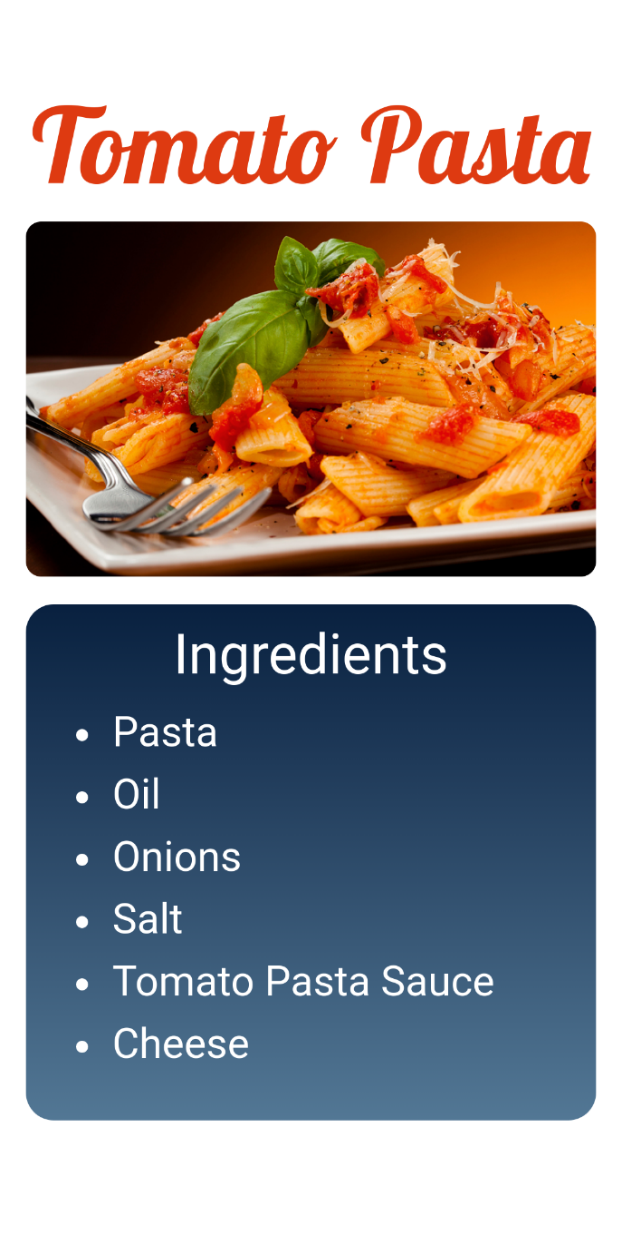

Medium (Size >= 768px), Large (Size >= 992px) and Extra Large (Size >= 1200px):

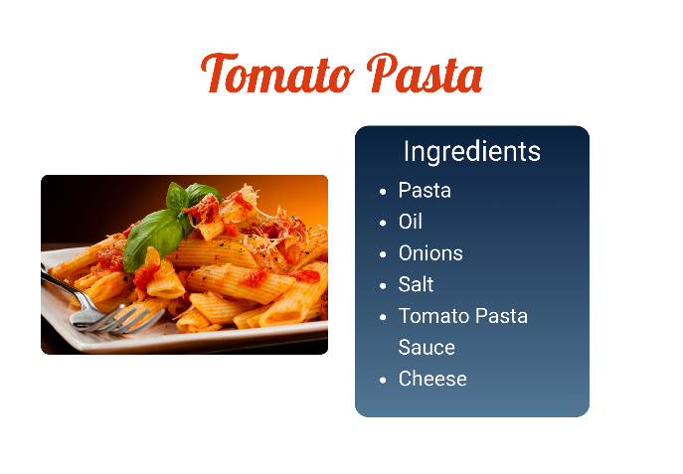

**Instructions**:

* Use the values of the recipeObj mentioned in the JS prefilled code to fill the text/image content of the given design
* The text content of the HTML main heading element with the class name recipe-title should be the value of the  title key given in the  recipeObj
* The HTML src attribute of the HTML img element should have the value of the imgSrc key given in the recipeObj
* Create HTML li elements as children to the HTML  ul element Dynamically.
* The text content of the HTML li elements should be the value of the ingredientskey given in the recipeObj

let recipeObj = {  
    title: "Tomato Pasta",  
    imgSrc: "<https://d1tgh8fmlzexmh.cloudfront.net/ccbp-dynamic-webapps/recipe-img.png>",  
    ingredients: ["Pasta", "Oil", "Onions", "Salt", "Tomato Pasta Sauce", "Cheese"]  
};